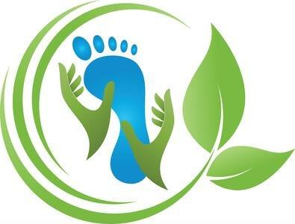Client Consent Form

**WHAT TO EXPECT**

Reflexology and Massage Therapy are non-invasive, complementary therapy that involves the application of pressure to specific points on the body with the goal of promoting relaxation and improving overall wellness. Reflexology and Massage treatments involve the use of touch, and the practitioner may need to touch sensitive areas of your feet or body to effectively treat the corresponding areas of the body. The treatment may also involve the use of lotion or oil on the body.

During a session, a trained practitioner will apply pressure on the body using their fingers, thumbs, hands, and forearms. The pressure is typically firm, but not painful, and may be accompanied by gentle stretching and massage techniques.

However, massage therapy is not a substitute for medical care, and practitioners do not diagnose medical condition(s) or prescribe medication.

**MEDICAL CONDITION**

It is your responsibility to inform your therapist of any medical conditions or concerns before your session. This includes any past surgeries, injuries, or chronic health conditions that you may have. By disclosing this information, you can help your therapist to tailor the session to your specific needs and ensure that the treatment is safe and effective for you.

**AREAS OF CONCERN –** Under Florida Law we are required to get written permission to work on different parts of the body. Please complete the following by initially the line that appears before each area of concern I may work in. State NO in areas you do not wish for me to work on. These options can be reviewed and changed at any time by completing a new form.

_____ Lymphatic brushing or massage brings consist of a light work to stimulate the lymph system and bringing it through the groin, sides of the body, armpits, over the clavicle and into the chest area.

_____ Stomach Massage for digestive health works the area from the diaphragm and into the pelvic girdle.

_____ Hip and Glute Work for the benefit of movement

_____ Psoas on the front of the pelvic girdle on both sides of the hip area

_____ Piriformis massage on the buttocks is deep work

_____ Bladder lift work, lower pelvic girdle

_____ Inner thigh work

* These items are used through the Judah Christian Healing Touch Methods of through God, by God, and with God as we believe that God created all things in this world for the benefit and health of all people.

**USE OF TOOLS AND OILS – PLEASE MARK AN X IN FRONT OF EACH ITEM.**

**____** Massage Oils **____** Essential Oils **____** Cool Eye Mask

**____** Hot Stone Placement Therapy **____** Himalayan Salt Stones for Massage

**____** Room Temp Crystal & Gem Stones* for Cool Stone Massage

**____** Energy Field Clearing* **____** Frequency Testing with Pendulum*

**BY SIGNING BELOW I ACKNOWLEDGE:**

I have consented to the massage treatments from a trained practitioner, understanding that it involves non-invasive pressure to promote relaxation and wellness. It is not a substitute for medical care and I should consult a physician if I have a medical condition.

I allow touch of general body parts along with the areas initialed above. I understand that the therapist will keep me connected during sessions that may include areas of concern to ensure I am aware of where touch may go. I understand that my private areas are to remain untouched and covered, and private at all times. I understand I have the right to stop any session should I become uncomfortable.

I understand and am responsible for my health and well-being. I agree to waive all liabilities toward my therapist for any injury or damages incurred due to misrepresentation due to my health history.

I understand that no sexual activity is permitted on the premises of this office and the therapist will discourage promiscuous behavior outside the office. If this behavior happens any and all future appointments will be cancelled or no allowed.

I understand it is the goal of the therapist to have a safe environment for body, mind, and soul of every client and for all others inside and outside of this office. I have had the opportunity to review this form, ask questions, and have them answered to my satisfaction.

_________________________ ______________________________ ___________

Client’s Print Name Client Signature Dated

Karen Groneberg___________ ______________________________ ___________

Therapist Print Name Therapist Signature Dated

Thank you for trusting Sweet Blessings Reflexology & Massage

